Game Design Document

Fill up the Following document

1. Write the title of your project.

Grow Moi

1. What is the goal of the game?

To plant more trees.

1. Write a brief story of your game?

You have a Garden and many seeds. Planting and taking care of a

Sapling is as good as taking care of a baby. You need to be patient

And understanding. When the tree matures, it give happiness and fruits. You get points according taking care of the plant. If you forget to do a specific task, you lose points.

1. Which are the playing characters of this game?

* Playing characters are the ones which respond to the user based on the input from the user
* Cars, monkeys, dinos, wizards etc, are the playing characters in the game.

|  |  |  |
| --- | --- | --- |
| Number | Character Name | What can this character do? |
| 1 | Seeds - Tree | Grows & gives Fruit |
| 2 |  |  |
| 3 |  |  |
| 4 |  |  |
| 5 |  |  |
| 6 |  |  |
| 7 |  |  |
| 8 |  |  |

1. Which are the Non Playing Characters of this game?

* Non Playing characters are the ones which don't have an action or a behaviour when the user interacts with the game.
* Hurdles, stones, bananas, coins, etc are non playing characters in the game.

|  |  |  |
| --- | --- | --- |
| Number | Character Name | What can this character do? |
| 1 | Fresh Soil | Makes the plant fresh |
| 2 | Water | Makes the plant greener |
| 3 |  |  |
| 4 |  |  |
| 5 |  |  |
| 6 |  |  |
| 7 |  |  |
| 8 |  |  |

Draw your imagination of this game. What does this game look like?

* Draw the game either on your computer or on paper,
* Add images of scenes of the game to show each of the playing and non-playing characters at least once.

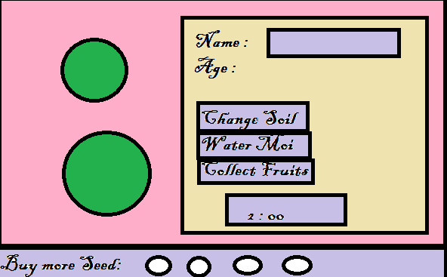

How do you plan to make your game engaging?

You get new plants. All with different timers. Day time reduces by 5 seconds every time the plant matures.

Flow of the Game:

When you open the game, you get many options for which seed you want. You can name it, water it (it will grow), change the soil (be a little greener).

When your plant matures, it gives you fruits.

Rules of the Game:

1st Plant Day time = 1 mins.

2nd Plant Day time = 2 mins.

Water the plant once in a day, for it to grow.

Change the soil every alternate day, for it to be greener.

Complete all the days task (on time) to get 5 points.

If not, minus 2 points (every task).

After the timer reaches to 0 seconds, you get fruits.

While waiting for the day to end, you can buy more plants.